**LINEAR REGRESSION ASSIGNMENT QUIZ BC=23010101**

* **How many employees having more than 5 years experience are earning more than 60000?**

**Marked Answer :**

14

**Correct Answer :**

**14**

**TOTAL MARKS : 1MARKS OBTAINED  1**

* How many employees are earning between 50000-80000?

**Marked Answer :**

12

**Correct Answer :**

**12**

**TOTAL MARKS : 1MARKS OBTAINED  1**

* **The scatter plot in the following image shows the relationship between the  
  “YearsExperience” and “Salary” columns. What possible inferences can be drawn from the  
  plot?**

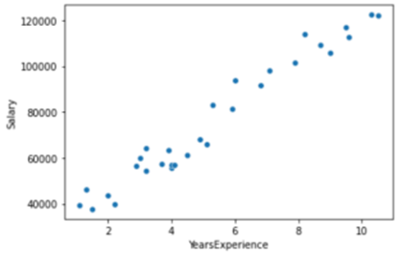

**Marked Answer :**

The plot shows a positive correlation between the ‘YearsExperience” and “Salary” column.

**Correct Answer :**

**The plot shows a positive correlation between the ‘YearsExperience” and “Salary” column.**

**TOTAL MARKS : 1MARKS OBTAINED  1**

* The distribution plot of the column “YearsExperience” is shown in the image below, what possible inferences can be drawn from the plot.

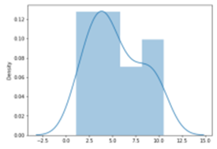

**Marked Answer :**

“YearsExperience” data is positively skewed.

**Correct Answer :**

**“YearsExperience” data is positively skewed.**

**TOTAL MARKS : 1MARKS OBTAINED  1**

* What all inferences can be drawn from the table shown below:

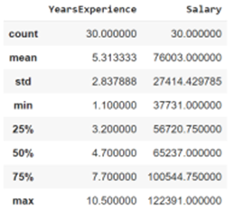

**Marked Answer :**

The range of the “YearsExperience” and “Salary” data is (9.4 , 84660 )

**Correct Answer :**

**The range of the “YearsExperience” and “Salary” data is (9.4 , 84660 )**

**TOTAL MARKS : 1MARKS OBTAINED  1**

* **To split the dataset into training and testing data, if we use the following  
  code. X = data[‘YearsExperience’]  
  y = data[‘Salary’]  
  X_train, X_test, y_train, y_test = train_test_split(X, y, test_size=0.2,  
  random_state=0) What does it mean when we write the test size as 0.2?**

**Marked Answer :**

The training data will consist of 80% of the samples from the total population.

**Correct Answer :**

**The training data will consist of 80% of the samples from the total population.**

**TOTAL MARKS : 1MARKS OBTAINED  1**

* **In the above example code, we have taken the random state as 0, if we change the  
  random state as 42, what does it mean for our training and testing data?**

**Marked Answer :**

The random state does not have any effect on the shape of the data.

**Correct Answer :**

**The random state does not have any effect on the shape of the data.**

**TOTAL MARKS : 1MARKS OBTAINED  1**

* **If the r2 score calculated in the above example is 0.98 , change the sample size of  
  the training and testing set in the ratio 60:40, and build a linear regression model again.  
  After plotting the best fit line on the test data, calculate the r2_score for the new model.**

**Marked Answer :**

0.96

**Correct Answer :**

**0.96**

**TOTAL MARKS : 1MARKS OBTAINED  1**

* **If while fitting the model with training and testing data, you get the following error  
  ValueError: Expected 2D array, got 1D array instead: What could be  
  the issue with the data, and how can you solve it?**

**Marked Answer :**

Reshape the data to a two dimensional array

**Correct Answer :**

**Reshape the data to a two dimensional array**

**TOTAL MARKS : 1MARKS OBTAINED  1**

* **The exercise after this contains questions that are based on the housing dataset.**

How many houses have a waterfront?

**Marked Answer :**

163

**Correct Answer :**

**163**

**TOTAL MARKS : 1MARKS OBTAINED  1**

* **The exercise after this contains questions that are based on the housing dataset.**

**How many houses have 2 floors?**

**Marked Answer :**

8241

**Correct Answer :**

**8241**

**TOTAL MARKS : 1MARKS OBTAINED  1**

* **The exercise after this contains questions that are based on the housing dataset.**

How many houses built before 1960 have a waterfront?

**Marked Answer :**

80

**Correct Answer :**

**80**

**TOTAL MARKS : 1MARKS OBTAINED  1**

* **The exercise after this contains questions that are based on the housing dataset.**

What is the price of the most expensive house having more than 4 bathrooms?

**Marked Answer :**

7700000

**Correct Answer :**

**7700000**

**TOTAL MARKS : 1MARKS OBTAINED  1**

* **The exercise after this contains questions that are based on the housing dataset.**

The image shown below shows the boxplot of the price column from the housing dataset. What inferences can you make from the plot?

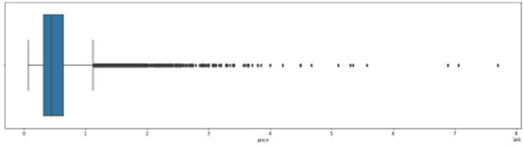

**Marked Answer :**

There is a presence of outliers in the price data.

**Correct Answer :**

**There is a presence of outliers in the price data.**

**TOTAL MARKS : 1MARKS OBTAINED  1**

* **The exercise after this contains questions that are based on the housing dataset.**

**For instance, if the ‘price’ column consists of outliers, how can you make the data clean and remove the redundancies?**

**Marked Answer :**

Calculate the IQR range and drop the values outside the range.

**Correct Answer :**

**Calculate the IQR range and drop the values outside the range.**

**TOTAL MARKS : 1MARKS OBTAINED  1**

* **The exercise after this contains questions that are based on the housing dataset.**

**What are the various parameters that can be used to determine the dependent variables in the housing data to determine the price of the house?**

**Marked Answer :**

Correlation coefficients

**Correct Answer :**

**Correlation coefficients**

**TOTAL MARKS : 1MARKS OBTAINED  1**

* **The exercise after this contains questions that are based on the housing dataset.**

If we get the r2 score as 0.38, what inferences can we make about the model and its efficiency?

**Marked Answer :**

High difference between observed and fitted values.

**Correct Answer :**

**High difference between observed and fitted values.**

**TOTAL MARKS : 1MARKS OBTAINED  1**

* **The exercise after this contains questions that are based on the housing dataset.**

If the metrics show that the p-value for the grade column is 0.092, what all inferences can we make about the grade column?

**Marked Answer :**

Significant in presence of other variables.

**Correct Answer :**

**Significant in presence of other variables.**

**TOTAL MARKS : 1MARKS OBTAINED  1**

* **The exercise after this contains questions that are based on the housing dataset.**

If the Variance Inflation Factor value for a feature is considerably higher than the other features, what can we say about that column/feature?

**Marked Answer :**

High multicollinearity

**Correct Answer :**

**High multicollinearity**

**TOTAL MARKS : 1MARKS OBTAINED  1**

Total Marks**19 / 19**